TC03: Verify CMM xml for the processed source JSON on IIB and verify Canonical xml with Mapping 1.4 after reverting the code version 1.5 in QA..

Source JSON-

{"orderNumber":"18182589","versionNumber":2,"orderStatus":"PAYMENT_REQUESTED","orderStatusReasonCode":"CUS_RESCEDULE_CANCEL","messageAction":"UPDATE","messageActionReason":"","companyId":"1","banner":"JewelOsco","isActive":true,"storeNumber":"0607","orderCreatedDate":"2020-08-13T07:51:11.179Z","fulfillmentSystem":"MANHATTAN","sourceInfo":{"source":"ECOMMERCE","enteredBy":"CUSTOMER","deviceType":"MOBILE","affiliate":{"affiliateName":"IBOTTA","affiliateOrderRef":"A123544334-123"}},"orderTotal":{"amount":"263.56","currency":"USD","totalCardSavings":15.51,"cardSavings":[{"savingsCategoryId":123,"savingsCategoryName":"String","savingsAmount":12.23}]},"customer":{"customerId":"556-020-1586122641346","clubCardNumber":"49130429968","isSubscription":false,"memberId":"1231321323","name":{"firstName":"JASON","lastName":"GRESS"},"address":[{"addressType":"SHIPTO","addressLine1":"14448 Donna Ln","addressLine2":" ","city":"Saratoga","state":"CA","zipCode":"95070","country":"USA"}],"contact":[{"number":"4088577000","type":"MOBILE"}],"email":[{"id":"gressholdings@gmail.com","type":"PERSONAL"}],"preference":{"termsCheckedVersionId":"0","optIn":[{"id":"4088577000","type":"TEXT","isOptin":true}]}},"paymentDetails":[{"paymentType":"CREDITCARD","paymentSubType":"AMEX","tokenNumber":"846787175413009","cardExpiryMonth":"10","cardExpiryYear":"24","zipcode":"95070","reqAuthorizationAmount":"263.56","cardHolderName":"Jason Gress","address":{"zipCode":"95070"},"paymentStatus":{"status":"NOTAUTHORIZED","authorizationCode":"201946","authorizationDate":"2020-08-13T07:51:11.233Z"}}],"subOrders":[{"subOrderNumber":1,"subOrderStatusReasonCode":"RESCHEDULE_SLOT","messageAction":"UPDATE","messageActionReason":"RESCHEDULE_SLOT","fulfillmentType":"DELIVERY","customerService":{"contact":[{"number":"8775054040","type":"PHONE","subType":"CUST_SERV_PHONE"}]},"deliveryInfo":{"deliverySubType":"RESIDENTIAL","slotInfo":{"slotPlan":"STANDARD","slotType":"FOURHR","slotId":"95e9bd9c-bedd-41ac-b0ad-04bebd4d7eb9","timeZone":"America/Los_Angeles","startTime":"2020-08-13T15:01:00.000Z","endTime":"2020-08-13T19:00:00.000Z","shiftNumber":"7","lastPickupTime":"2020-03-25T20:00:00.000Z","editingCutoffDate":"2020-08-13T08:00:00.000Z"},"deliveryServiceType":"ATTENDED","instructions":"","stageByDateTime":"2020-08-13T14:21:00.000Z","pickupInfo":{"locationType":"STORE","locationId":"1211","shortOrderNumber":4}},"charges":[{"id":"0000000029103","name":"BagFee","category":"ServiceFee","chargeAmount":{"amount":"0.1","currency":"USD"}},{"id":"0000000022155","name":"DeliveryFee","category":"DeliveryFee","chargeAmount":{"amount":"3.95","currency":"USD"}}],"promoCodes":[{"code":"SAVE20","description":"$20 Off Orders Over $75","pluCode":"00001234"}],"routeInfo":{"vanNumber":"DDS","stopNumber":"377"},"tote":{"toteEstimate":{"chilled":6,"frozen":2,"ambient":7},"toteDetails":[{"toteId":"","item":[]},{"toteId":"99800400215899","item":[{"itemId":"960027187","fulfilledUpc":[{"upcId":"003320009471","upcQuantity":1,"scannedUpc":"033200094715","pickedBy":"SYSTEM","pickedDate":"2020-08-13T09:38:01.782Z","pickType":"REGULAR"}]}]}],"totalPickedToteCount":4,"totalNumberOfBagsUsed":5},"orderLines":[{"itemId":"196011495","itemDescription":"San Luis Sourdough Bread Round - 24 Oz","orderedQuantity":1,"shortedQuantity":0,"fulfilledQuantity":1,"unitOfMeasure":"OZ","unitPrice":{"amount":"4.99","currency":"USD"},"substitutionCode":"2","substitutionValue":"Same Brand Diff Size","isRegulatedItem":false,"comments":"","fulfilledUpc":[{"upcId":"001853724157","entryId":100,"upcQuantity":1,"pickedBy":"SYSTEM","pickedDate":"2020-08-13T09:38:01.782Z","pickType":"REGULAR","scanPrice":2.33,"isSubstituted":false,"itemPrice":{"itemCode":"UPC","entryId":100,"department":30,"unitPrice":20.5,"extendedPrice":5.5,"quantityType":"LB","quantityValue":4.45,"discountAllowed":true,"linkPluNumber":"66666666","startDate":"2020-08-13T09:38:01.782Z","endDate":"2020-08-14T09:38:01.782Z","itemPluNumber":"embedded item PLU1","pointsApplyItem":true,"wic":false,"substituted":false,"netPromotionAmount":205.49,"savings":[{"offerId":"463272","externalOfferId":"463274","category":1,"source":"CPE","linkpluNumber":"promo PLU","programCode":"SC","startDate":"2020-08-13T07:00:00.000+0000","endDate":"2020-08-14T07:00:00.000+0000","discountAmount":14.94,"discountType":"Free","description":"Default Description","discountMessage":"discount","discountLevel":"Item Level","promotionPrice":2.59,"netPromotionAmount":8.43,"points":[{"programName":"String","earn":1,"burn":1}]}]}},{"upcId":"001853724157","entryId":200,"upcQuantity":1,"pickedBy":"SYSTEM","pickedDate":"2020-08-13T09:38:01.782Z","pickType":"REGULAR","scanWeight":3.98,"isSubstituted":true,"itemPrice":{"itemCode":"UPC","entryId":100,"department":30,"unitPrice":20.5,"extendedPrice":5.5,"quantityType":"LB","quantityValue":4.45,"discountAllowed":true,"linkPluNumber":"3444443333","startDate":"2020-08-13T09:38:01.782Z","endDate":"2020-08-14T09:38:01.782Z","itemPluNumber":"embedded item PLU2","pointsApplyItem":true,"wic":false,"substituted":false,"netPromotionAmount":205.49,"savings":[{"offerId":"463272","externalOfferId":"463274","category":1,"source":"CPE","linkpluNumber":"promo PLU","programCode":"SC","startDate":"2020-08-13T07:00:00.000+0000","endDate":"2020-08-14T07:00:00.000+0000","discountAmount":14.94,"discountType":"Free","description":"Default Description","discountMessage":"discount","discountLevel":"Item Level","promotionPrice":2.59,"netPromotionAmount":8.43,"points":[{"programName":"String","earn":1,"burn":1}]}]}}],"itemPrice":{"itemCode":"UPC","entryId":100,"department":30,"unitPrice":20.5,"extendedPrice":5.5,"quantityType":"LB","quantityValue":4.45,"discountAllowed":true,"linkPluNumber":"2223446555","startDate":"2020-08-13T09:38:01.782Z","endDate":"2020-08-14T09:38:01.782Z","itemPluNumber":"embedded item PLU3","pointsApplyItem":true,"wic":false,"substituted":false,"netPromotionAmount":205.49,"savings":[{"offerId":"463272","externalOfferId":"463274","category":1,"source":"CPE","linkpluNumber":"promo PLU","programCode":"SC","startDate":"2020-08-13T07:00:00.000+0000","endDate":"2020-08-14T07:00:00.000+0000","discountAmount":14.94,"discountType":"Free","description":"Default Description","discountMessage":"discount","discountLevel":"Item Level","promotionPrice":2.59,"netPromotionAmount":8.43,"points":[{"programName":"String","earn":1,"burn":1}]}]}}]}],"storeInfo":[{"key":"isHybridStore","value":"true"},{"key":"isMFC","value":"false"},{"key":"isErumsEnabled","value":"true"},{"key":"isPremiumStore","value":"true"},{"key":"is3PLStore","value":"true"},{"key":"isDUGArrivalEnabled","value":"false"},{"key":"storeTimeZone","value":"PST"},{"key":"terminalNumber","value":"99"},{"key":"isWYSIWYGEnabled","value":"true"}],"orderInfo":{"stageByDateTime":"2020-08-13T14:21:00.000Z","data":[{"key":"key","value":"value"}]},"audit":{"createDate":"2020-08-13T12:27:32.039Z","modifiedDate":"2020-08-13T12:27:32.039Z","createdBy":"OSCO-SERVICES"}}

Publish Source message on kafka-

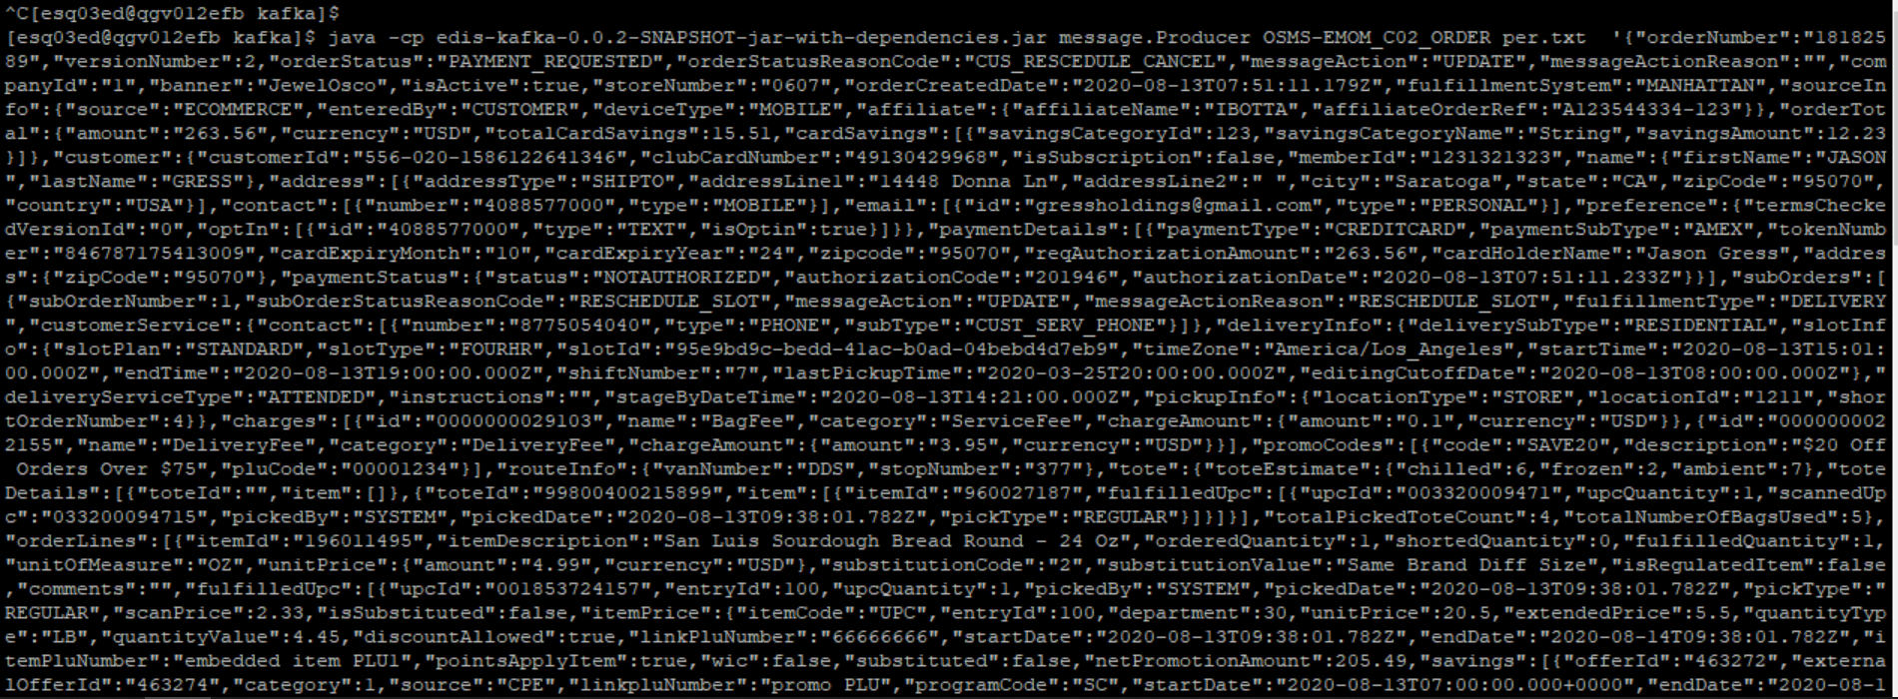

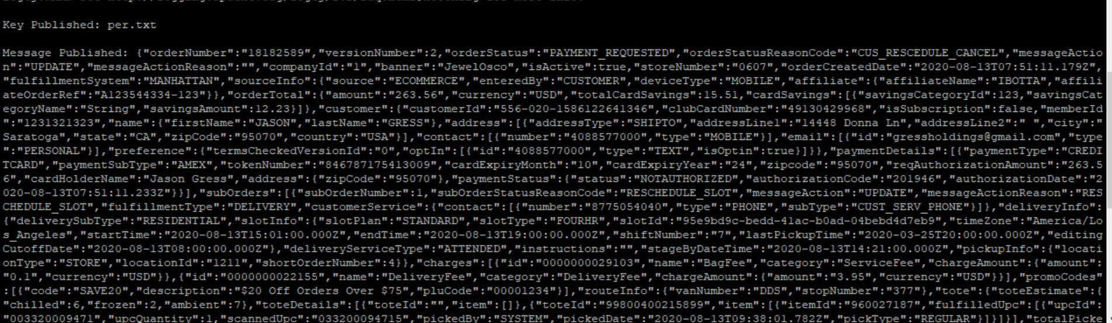

Consume source message on Kafka-

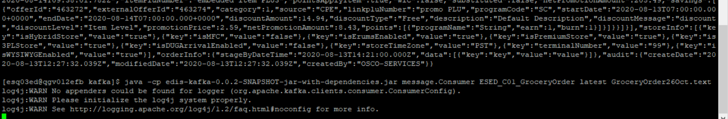

Verify the record in Audit table-

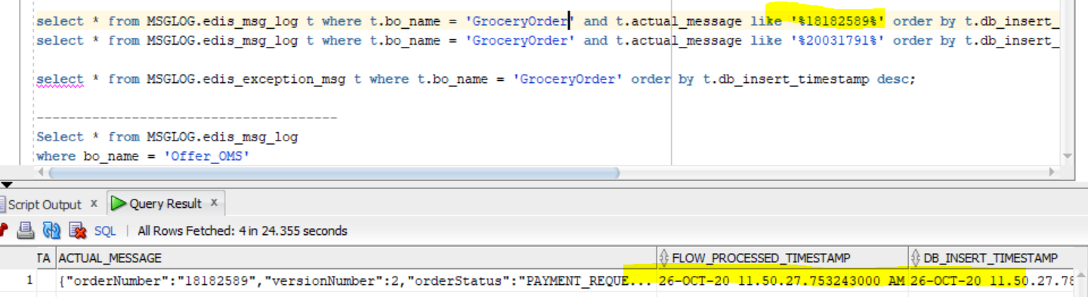

Output CMM xml-

<GetGroceryOrder

xmlns:Abs="https://collab.safeway.com/it/architecture/info/default.aspx">

<DocumentData>

<Abs:Document VersionId="1.4.0.31" SystemEnvironmentCd="QA">

<Abs:DocumentID>GROCERY_ORDER</Abs:DocumentID>

<Abs:AlternateDocumentID>OSMS-EMOM_C02_ORDER-20201026115027756919</Abs:AlternateDocumentID>

<Abs:DocumentNm>GroceryOrder</Abs:DocumentNm>

<Abs:CreationDt>2020-10-26T11:50:27.756919</Abs:CreationDt>

<Abs:Description>GroceryOrderDetail</Abs:Description>

<Abs:SourceApplicationCd>eRUMS</Abs:SourceApplicationCd>

<Abs:TargetApplicationCd>EDIS</Abs:TargetApplicationCd>

<Abs:InternalFileTransferInd>Y</Abs:InternalFileTransferInd>

<Abs:DataClassification>

<Abs:DataClassificationLevel>

<Abs:Code>Internal</Abs:Code>

</Abs:DataClassificationLevel>

<Abs:BusinessSensitivityLevel>

<Abs:Code>Low</Abs:Code>

</Abs:BusinessSensitivityLevel>

<Abs:PHIdataInd>N</Abs:PHIdataInd>

<Abs:PCIdataInd>Y</Abs:PCIdataInd>

<Abs:PIIdataInd>Y</Abs:PIIdataInd>

</Abs:DataClassification>

</Abs:Document>

<Abs:DocumentAction>

<Abs:ActionTypeCd>UPDATE</Abs:ActionTypeCd>

<Abs:RecordTypeCd>CHANGE</Abs:RecordTypeCd>

</Abs:DocumentAction>

</DocumentData>

<GroceryOrderData>

<Abs:GroceryOrderHeader>

<Abs:OrderId>18182589</Abs:OrderId>

<Abs:OrderCreateTS>2020-08-13T07:51:11.179Z</Abs:OrderCreateTS>

<Abs:CompanyId>1</Abs:CompanyId>

<Abs:VersionNbr>2</Abs:VersionNbr>

<Abs:OrderStatus>

<Abs:StatusTypeCd>PAYMENT_REQUESTED</Abs:StatusTypeCd>

</Abs:OrderStatus>

<Abs:OrderActionStatus>

<Abs:StatusTypeCd>UPDATE</Abs:StatusTypeCd>

<Abs:Description></Abs:Description>

</Abs:OrderActionStatus>

<Abs:FulfillingFacility>

<Abs:RetailStoreId>0607</Abs:RetailStoreId>

<Abs:BannerCd>JewelOsco</Abs:BannerCd>

<Abs:HybridStoreInd>Y</Abs:HybridStoreInd>

<Abs:MFCInd>N</Abs:MFCInd>

<Abs:ERUMSEnabledInd>Y</Abs:ERUMSEnabledInd>

<Abs:PremiumStoreInd>Y</Abs:PremiumStoreInd>

<Abs:ThirdPartyDeliveryOnlyInd>Y</Abs:ThirdPartyDeliveryOnlyInd>

</Abs:FulfillingFacility>

<Abs:GroceryOrderProfileType>

<Abs:ProfileType>

<Abs:Code>WYSIWYG</Abs:Code>

</Abs:ProfileType>

<Abs:ProfileValueInd>true</Abs:ProfileValueInd>

</Abs:GroceryOrderProfileType>

<Abs:RetailCustomer>

<Abs:CustomerId>556-020-1586122641346</Abs:CustomerId>

<Abs:CustomerNm>

<Abs:GivenNm>Q8xxD</Abs:GivenNm>

<Abs:FamilyNm>BDHT5</Abs:FamilyNm>

</Abs:CustomerNm>

<Abs:Contact>

<Abs:PhoneFaxContact TypeCode="MOBILE">

<Abs:PhoneNbr>4D4zGn6g9l</Abs:PhoneNbr>

</Abs:PhoneFaxContact>

</Abs:Contact>

<Abs:Contact>

<Abs:DigitalContact>

<Abs:DigitalAddress>pJDqsSHBOyNqW@Vydgj.8qp</Abs:DigitalAddress>

<Abs:EmailStatuses Abs:typeCode="PERSONAL"/>

</Abs:DigitalContact>

</Abs:Contact>

<Abs:Contact>

<Abs:Address>

<Abs:AddressUsageTypeCd>epgjqg</Abs:AddressUsageTypeCd>

<Abs:AddressLine1txt>lgG9T iBOZy P6</Abs:AddressLine1txt>

<Abs:AddressLine2txt></Abs:AddressLine2txt>

<Abs:CityNm>eNozeohY</Abs:CityNm>

<Abs:PostalZoneCd>t61WJ</Abs:PostalZoneCd>

<Abs:StateCd>Hpz</Abs:StateCd>

<Abs:CountryCd>USA</Abs:CountryCd>

</Abs:Address>

</Abs:Contact>

<Abs:ClubCardNbr>9LPMIqnFAJN</Abs:ClubCardNbr>

<Abs:CustomerPreference>

<Abs:PreferenceType>

<Abs:Code>TEXT</Abs:Code>

</Abs:PreferenceType>

<Abs:OptInContactNbr>4088577000</Abs:OptInContactNbr>

<Abs:OptInInd>true</Abs:OptInInd>

</Abs:CustomerPreference>

<Abs:CustomerSubscription>

<Abs:OptInInd>false</Abs:OptInInd>

</Abs:CustomerSubscription>

</Abs:RetailCustomer>

<Abs:CurrencyCd>USD</Abs:CurrencyCd>

<Abs:TotalAmt>263.56</Abs:TotalAmt>

<Abs:CustomerPayment>

<Abs:Tender>

<Abs:TenderId>YjQXWIpp4Uc9XX4</Abs:TenderId>

<Abs:TenderTypeCd>CREDITCARD</Abs:TenderTypeCd>

<Abs:TenderSubTypeCd>AMEX</Abs:TenderSubTypeCd>

<Abs:HolderNm>C9loT cjVtc</Abs:HolderNm>

<Abs:ExpireMonthYearTxt>xkdx</Abs:ExpireMonthYearTxt>

<Abs:BillingAddress>

<Abs:PostalZoneCd>t61WJ</Abs:PostalZoneCd>

</Abs:BillingAddress>

<Abs:PostalCd>sBhJC</Abs:PostalCd>

<Abs:Token>

<Abs:TokenId>YjQXWIpp4Uc9XX4</Abs:TokenId>

<Abs:TokenTypeCd>CREDITCARD</Abs:TokenTypeCd>

</Abs:Token>

<Abs:Status>

<Abs:StatusCd>NOTAUTHORIZED</Abs:StatusCd>

</Abs:Status>

<Abs:RequiredAuthAmt>263.56</Abs:RequiredAuthAmt>

<Abs:AuthCd>RzmCI2</Abs:AuthCd>

<Abs:AuthDt>2020-08-13T07:51:11.233Z</Abs:AuthDt>

</Abs:Tender>

</Abs:CustomerPayment>

<Abs:CustomerSavings>

<Abs:SavingsCategoryType>

<Abs:SavingsCategoryId>123</Abs:SavingsCategoryId>

<Abs:SavingsCategoryNm>String</Abs:SavingsCategoryNm>

<Abs:SavingsAmt>12.23</Abs:SavingsAmt>

</Abs:SavingsCategoryType>

</Abs:CustomerSavings>

<Abs:OrderRecordDateInfo>

<Abs:CreateUserId>CUSTOMER</Abs:CreateUserId>

</Abs:OrderRecordDateInfo>

<Abs:OrderCreatedDeviceType>

<Abs:Code>MOBILE</Abs:Code>

</Abs:OrderCreatedDeviceType>

<Abs:AffiliatePartnerType>

<Abs:AffiliatePartnerNm>IBOTTA</Abs:AffiliatePartnerNm>

<Abs:OrderReferenceTxt>A123544334-123</Abs:OrderReferenceTxt>

</Abs:AffiliatePartnerType>

<Abs:OrderSourceSystemType>

<Abs:Code>ECOMMERCE</Abs:Code>

</Abs:OrderSourceSystemType>

</Abs:GroceryOrderHeader>

<Abs:GrocerySubOrder>

<Abs:SubOrderNbr>1</Abs:SubOrderNbr>

<Abs:SubOrderStatus/>

<Abs:SubOrderActionStatus>

<Abs:StatusTypeCd>UPDATE</Abs:StatusTypeCd>

<Abs:Description>RESCHEDULE_SLOT</Abs:Description>

</Abs:SubOrderActionStatus>

<Abs:GroceryOrderDetail>

<Abs:CartLineNbr>100</Abs:CartLineNbr>

<Abs:ItemId>

<Abs:SystemSpecificItemId>196011495</Abs:SystemSpecificItemId>

<Abs:InternalItemId>UPC</Abs:InternalItemId>

<Abs:BaseProductNbr>196011495</Abs:BaseProductNbr>

<Abs:ItemDescription>San Luis Sourdough Bread Round - 24 Oz</Abs:ItemDescription>

</Abs:ItemId>

<Abs:UnitPriceAmt>4.9900</Abs:UnitPriceAmt>

<Abs:ExtendedUnitPriceAmt>5.5000</Abs:ExtendedUnitPriceAmt>

<Abs:Quantity>1.0000</Abs:Quantity>

<Abs:UOM>

<Abs:UOMCd>OZ</Abs:UOMCd>

</Abs:UOM>

<Abs:DiscountAllowedInd>true</Abs:DiscountAllowedInd>

<Abs:RewardAllowedInd>true</Abs:RewardAllowedInd>

<Abs:SubstitutionType>

<Abs:Code>2</Abs:Code>

<Abs:Description>Same Brand Diff Size</Abs:Description>

</Abs:SubstitutionType>

<Abs:CurrencyCd>USD</Abs:CurrencyCd>

<Abs:RegulatedItemInd>false</Abs:RegulatedItemInd>

<Abs:LinkPLUNbr>2223446555</Abs:LinkPLUNbr>

<Abs:CouponPLUNbr>embedded item PLU3</Abs:CouponPLUNbr>

<Abs:CustomerOffers>

<Abs:OfferId>463272</Abs:OfferId>

<Abs:OfferSourceType>

<Abs:Code>CPE</Abs:Code>

</Abs:OfferSourceType>

<Abs:CustomerRewards>

<Abs:RewardsProgramNm>String</Abs:RewardsProgramNm>

<Abs:EarnedQty>1</Abs:EarnedQty>

<Abs:UsedQty>1</Abs:UsedQty>

</Abs:CustomerRewards>

</Abs:CustomerOffers>

<Abs:Department>

<Abs:Code>30</Abs:Code>

</Abs:Department>

<Abs:WICItemInd>false</Abs:WICItemInd>

<Abs:DeliveredItem>

<Abs:UOM/>

</Abs:DeliveredItem>

</Abs:GroceryOrderDetail>

<Abs:GroceryOrderDetail>

<Abs:PromotionType>

<Abs:Code>SAVE20</Abs:Code>

<Abs:Description>$20 Off Orders Over $75</Abs:Description>

</Abs:PromotionType>

<Abs:PromotionTriggerCd>00001234</Abs:PromotionTriggerCd>

</Abs:GroceryOrderDetail>

<Abs:FullFillmentType>

<Abs:Code>DELIVERY</Abs:Code>

</Abs:FullFillmentType>

<Abs:PickupInfo>

<Abs:PickupSlot>

<Abs:Code>1211</Abs:Code>

</Abs:PickupSlot>

<Abs:PickupSlotType>

<Abs:Code>STORE</Abs:Code>

</Abs:PickupSlotType>

<Abs:DisplayEndDttm>2020-03-25T20:00:00.000Z</Abs:DisplayEndDttm>

</Abs:PickupInfo>

<Abs:DeliveryInfo>

<Abs:CustomerType>

<Abs:Code>RESIDENTIAL</Abs:Code>

</Abs:CustomerType>

<Abs:DeliverySlotId>95e9bd9c-bedd-41ac-b0ad-04bebd4d7eb9</Abs:DeliverySlotId>

<Abs:DeliverySlotType>

<Abs:Code>FOURHR</Abs:Code>

</Abs:DeliverySlotType>

<Abs:DeliveryServiceType>

<Abs:Code>ATTENDED</Abs:Code>

</Abs:DeliveryServiceType>

<Abs:SlotPlan>

<Abs:Code>STANDARD</Abs:Code>

</Abs:SlotPlan>

<Abs:StartDttm>2020-08-13T15:01:00.000Z</Abs:StartDttm>

<Abs:EndDttm>2020-08-13T19:00:00.000Z</Abs:EndDttm>

<Abs:SlotExpiryDttm>2020-08-13T19:00:00.000Z</Abs:SlotExpiryDttm>

<Abs:StageByDttm>2020-08-13T14:21:00.000Z</Abs:StageByDttm>

<Abs:EditCutoffDttm>2020-08-13T08:00:00.000Z</Abs:EditCutoffDttm>

<Abs:CustomerInstructionTxt></Abs:CustomerInstructionTxt>

<Abs:DeliveryTimeZoneCd>America/Los_Angeles</Abs:DeliveryTimeZoneCd>

</Abs:DeliveryInfo>

<Abs:ChargeInfo>

<Abs:Charge>

<Abs:Code>0000000029103</Abs:Code>

<Abs:Description>BagFee</Abs:Description>

</Abs:Charge>

<Abs:ChargeCategory>

<Abs:Code>ServiceFee</Abs:Code>

</Abs:ChargeCategory>

<Abs:ChargeAmt>0.10</Abs:ChargeAmt>

<Abs:CurrencyCd>USD</Abs:CurrencyCd>

</Abs:ChargeInfo>

<Abs:ChargeInfo>

<Abs:Charge>

<Abs:Code>0000000022155</Abs:Code>

<Abs:Description>DeliveryFee</Abs:Description>

</Abs:Charge>

<Abs:ChargeCategory>

<Abs:Code>DeliveryFee</Abs:Code>

</Abs:ChargeCategory>

<Abs:ChargeAmt>3.95</Abs:ChargeAmt>

<Abs:CurrencyCd>USD</Abs:CurrencyCd>

</Abs:ChargeInfo>

<Abs:CustomerService>

<Abs:PhoneFaxContact TypeCode="PHONE">

<Abs:PhoneNbr>8775054040</Abs:PhoneNbr>

<Abs:PhonePurposes>

<Abs:PurposeDsc>CUST_SERV_PHONE</Abs:PurposeDsc>

</Abs:PhonePurposes>

</Abs:PhoneFaxContact>

</Abs:CustomerService>

</Abs:GrocerySubOrder>

</GroceryOrderData>

</GetGroceryOrder>